**Shredder Design**

**Outline:**

This machine can shred HDPE, PP, and PS. Films are too thin and will slide in between the blades. Rubber, tires, and thermoset plastics have not been tested. HDPE, PP, and PS can be shred from 0.7mm to 12mm as far as the tests conducted by Precious Plastics show.

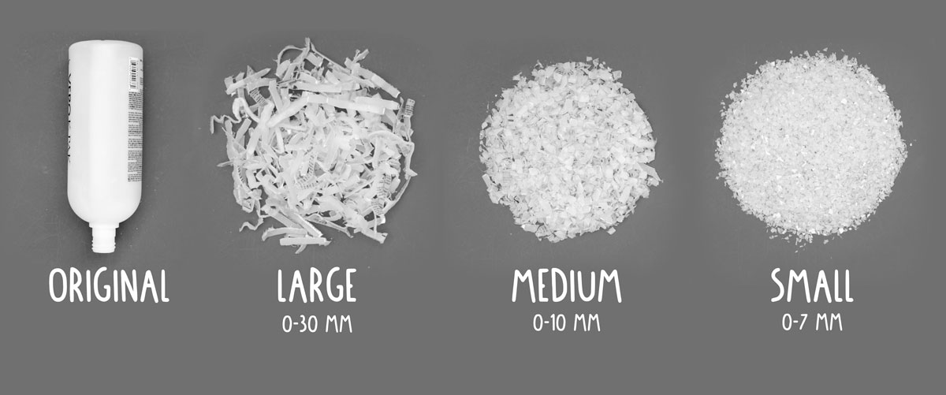

Below is a chart taken from the precious plastic website that outlines the sized required for the plastic to be shredded to for them to work on each type of machine.

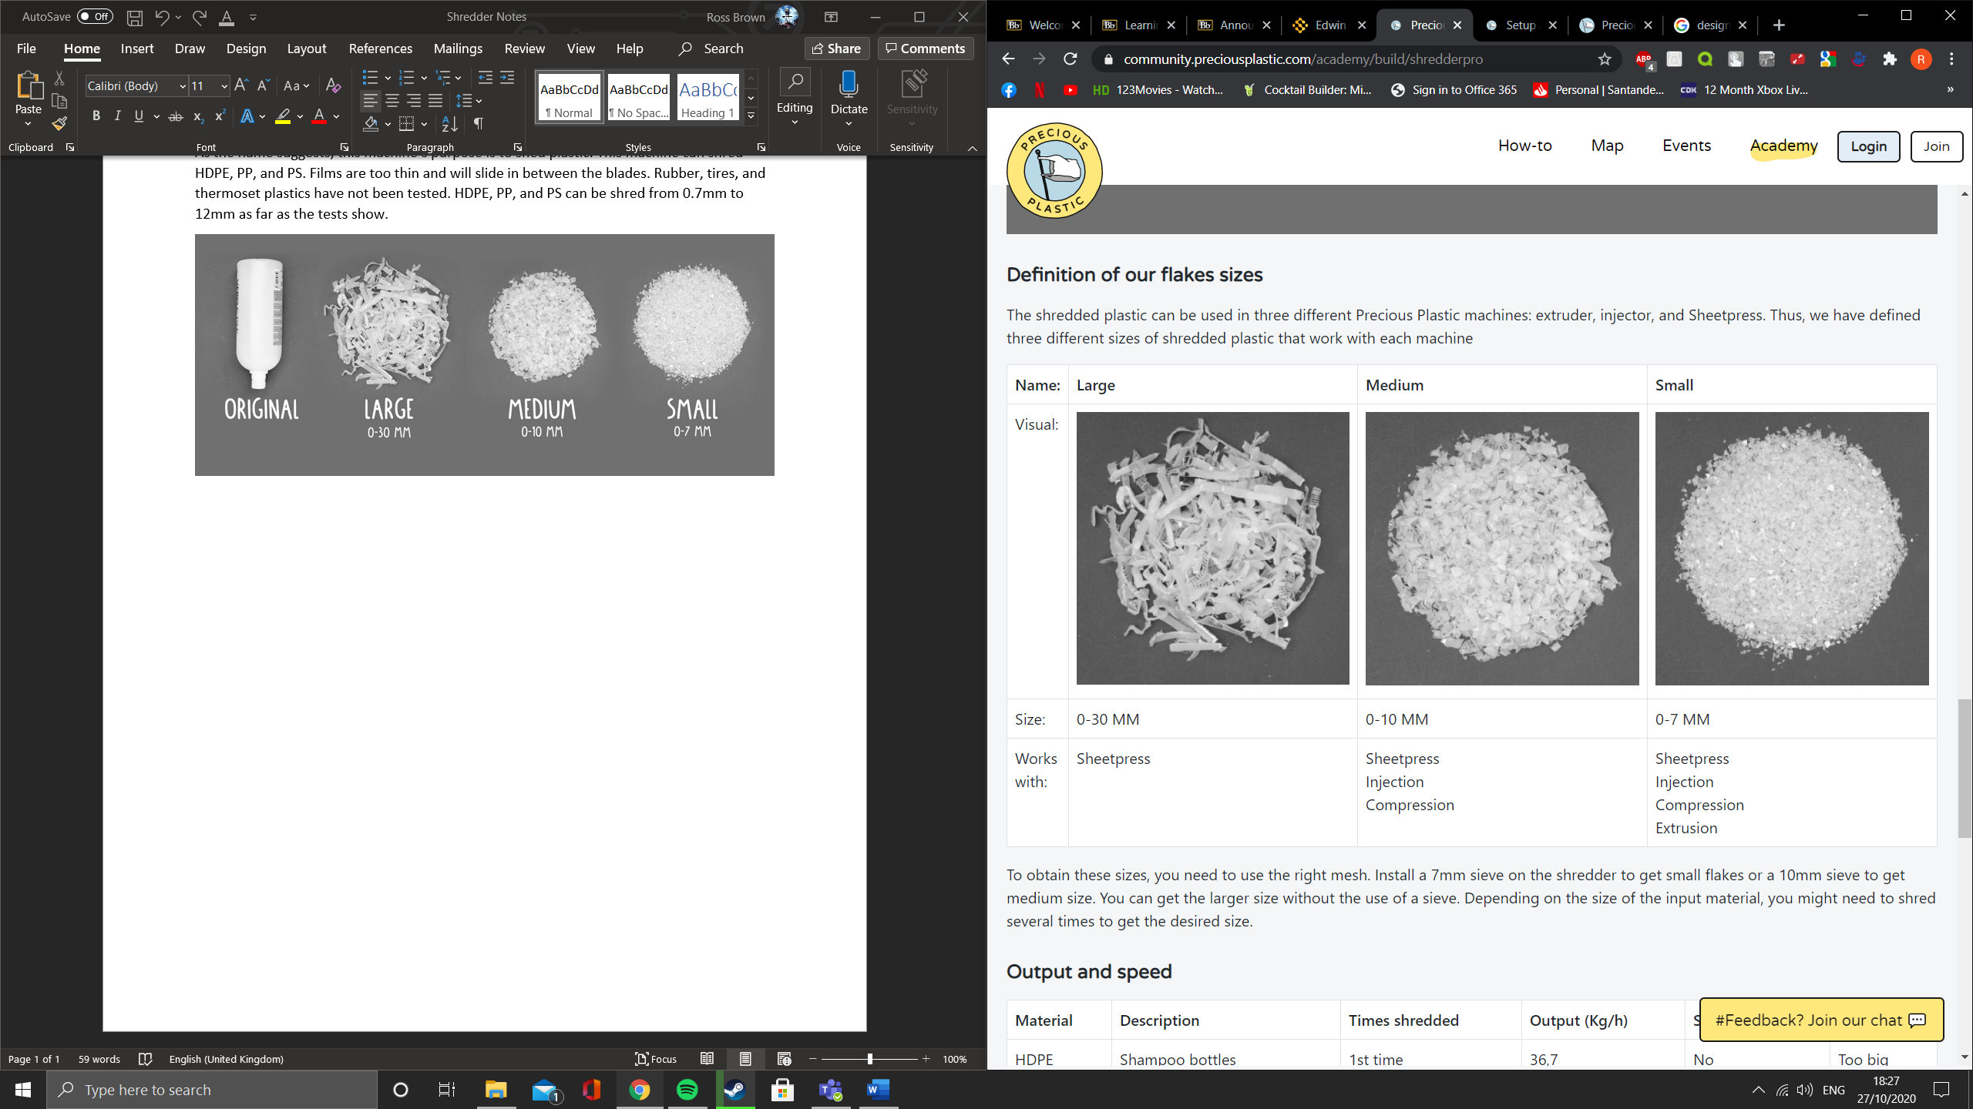

To reach the desired plastic size, you must change the mesh. For example, install a 7mm sieve on the shredder to get the smallest flakes. If you decide not to use a sieve, then you can obtain larger sized flakes. Depending on the plastic used on the input, you may need to shred the plastic several times.

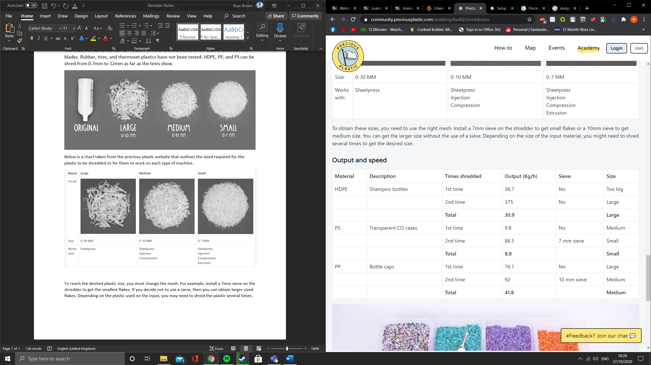

**List of Materials**

|  |  |  |  |
| --- | --- | --- | --- |
| **Item** | **Qty.** |  | **Price** |
| gears keyway machining | 2 |  | € 60.00 |
| mild steel, OD19mm x ID16mm | 0,3m |  | € 0.68 |
| mild steel, OD16mm x ID12mm | 2,1m |  | € 3.81 |
| mild steel, Tube 40 x 40 x 3mm | 6m |  | € 19.03 |
| mild steel, Tube 40 x 80 x 3mm | 6m |  | € 32.61 |
| laser cut, V4 shredder mild steel & Hardox | ALL |  | € 830.00 |
| mild steel, 50mm Hex Bar C45 | 1,8m |  | € 132.30 |
| DIN 912 M16 x 40 | 8 |  | € 6.48 |
| DIN 912 M16 x 30 | 4 |  | € 2.64 |
| M16 Washer | 12 |  | € 1.20 |
| DIN 912 M5 x 12mm | 6 |  | € 0.24 |
| M6 Washer | 4 |  | € 0.04 |
| DIN 912 M6 x 12mm | 17 |  | € 0.85 |
| M6 Nut | 13 |  | € 0.13 |
| M12 Threaded bar | 4 |  | € 14.20 |
| M12 Washer | 16 |  | € 0.64 |
| M12 Nut | 16 |  | € 1.44 |
| DIN 933 M10 x 40mm | 4 |  | € 0.72 |
| M10 Nut | 4 |  | € 0.24 |
| Slotted round nut DIN 1804 M50X1,50 | 4 |  | € 64.00 |
| 3 kW motor, with Bevelgear Type | 1 |  | € 1,300.00 |
| **OR** 2,2 kW motor, with Bevelgear Type | 1 |  | € 920.00 |
| full bridge rectifier 1A (DF10-G) | 1 |  | € 0.19 |
| 100uF capacitor 10V | 1 |  | € 0.42 |
| 10k resistors 1/4W | 2 |  | € 0.42 |
| 100k resistor 1/4W | 1 |  | € 0.16 |
| 2.2mF capacitor 10V | 1 |  | € 0.36 |
| Arduino nano | 1 |  | € 24.20 |
| 5V 2 channels relay module 250VAC | 1 |  | € 1.39 |
| ACS712 30A hall effect sensor module | 1 |  | € 8.99 |
| 3 position toggle switch | 1 |  | € 38.99 |
| 3 phase general switch | 1 |  | € 20.05 |
| Emergency stop switch with 3 NC connections | 1 |  | € 38.15 |
| Motor protective circuit breaker, 6,8 Amps | 1 |  | € 138.42 |
| 3 phase contactors, 3 NO and 1 NC connections | 2 |  | € 69.22 |
| 5V 500mA power supply | 1 |  | € 24.73 |
| Cable gland M25 | 4 |  | € 9.92 |
| DIN Rail Mount Terminal Block, 32 A | 10 |  | € 13.20 |
| DIN Rail | 0.6 |  | € 7.03 |
| 16A Male Plug | 1 |  | € 9.50 |
| H07 5 Multi-core Cable (6mm) | 1 |  | € 24.20 |
| bearings, UCFL 209 45mm | 6 |  | € 182.16 |
| Coupling FENNERHRC Elastomeric - hub size 230 - type F with tapered bore for Taper Lock 3020 | 2 |  | € 239.84 |
| FENNER Spider for HRC jaw coupling size 230 | 1 |  | € 54.26 |
| Taper Lock 3020-45 | 1 |  | € 25.96 |
| Taper Lock 3020-50 | 1 |  | € 25.96 |
| Spur Gears, Steel C45, Hardened Teeth, Module 6 18 teeth | 1 |  | € 108.90 |
| Spur Gears, Steel C45, Hardened Teeth, Module 6 20 teeth | 1 |  | € 108.90 |
| Parallel key A14 x 9 x 70 DIN 6885 | 2 |  | € 2.00 |
| Parallel key A14 x 9 x 80 DIN 6885 | 1 |  | € 1.00 |
|  |  | **Total without motor :** | **€ 2,350** |
|  |  | **Total with 3kW motor :** | **€ 3,650** |
|  |  | **Total with 2,2kW motor :** | **€ 3,270** |

**Method of Construction**

**Frame**

*Required Materials:*

* Square tubes
* Rectangular tubes
* Flat bar
* Corner
* Bolts

*Method:*

1. Cut all elements to the desired lengths.
2. Drill the holes for the cable management and the motors. For more critical holes, wait until after the welding is completed.
3. Line up the bars to make a rectangle and weld. Ensure that a right-angled protractor is used to ensure the frame is straight.
4. Weld the additional bars in the correct place to complete the frame.
5. Mark all the holes on the frame that you need to drill. Use the laser-cut plates to ensure that they line up with the holes on the plates. Then proceed to drill the holes.
6. Tac weld the legs to the assembled frame and then assemble the motor plate.
7. Clean the frame thoroughly then proceed to paint with the desired colour.

**Shaft**

*Required Materials:*

* Diagonal bars
* Nuts
* Blades

*Method:*

1. Place the bar into the lathe and create the thread for the nut. Once completed, check with the nut to ensure it fits onto the thread. Once the first side is completed, repeat the same steps on the other side.
   1. Drill some cylinders on it?
   2. Do this again for the second axis
2. Sand all the spacers and blades before assembly to ensure they fit.
   1. Start with the longer axis and firstly, use a screw. Leave 1mm clearance.
   2. On the shorter axis, place x2 4mm spacers down the shaft then 1x 2mm spacer.
   3. For the blade, use the sharper set of blades. Turn the blade by one face of the hexagon counter clockwise shape of the bar.
   4. Place 1 x 4mm spacer then x1 2mm spacer then add the next blade, ensuring it is rotated by one face each time.
   5. Repeat steps b and d until you have run out of blades?